

گزینه 1

--------------------------------------------------------------------------------------------------------------------------------------

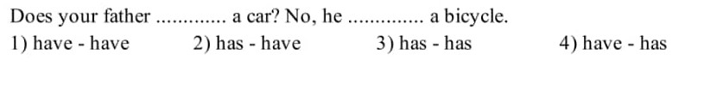

گزینه 4

--------------------------------------------------------------------------------------------------------------------------------------

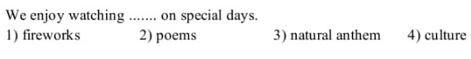

گزینه 1

--------------------------------------------------------------------------------------------------------------------------------------

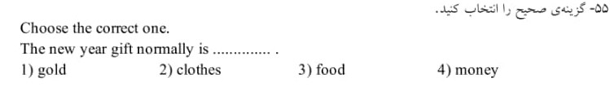

گزینه 4

--------------------------------------------------------------------------------------------------------------------------------------



گزینه 3

--------------------------------------------------------------------------------------------------------------------------------------



گزینه 4

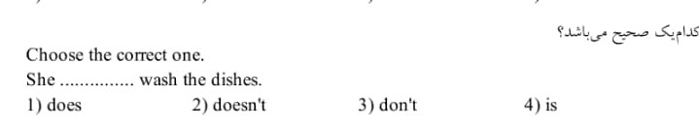

گزینه 2

--------------------------------------------------------------------------------------------------------------------------------------



گزینه 3

--------------------------------------------------------------------------------------------------------------------------------------



گزینه 2

--------------------------------------------------------------------------------------------------------------------------------------



گزینه 4